**Registration Form**

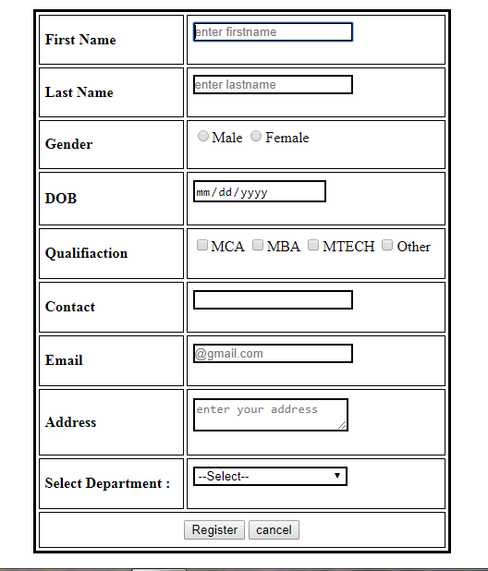

**Login Form**

